MISEOS
CANON BIBLE v1.0
Authoritative character, world, visual, metadata and publishing standard
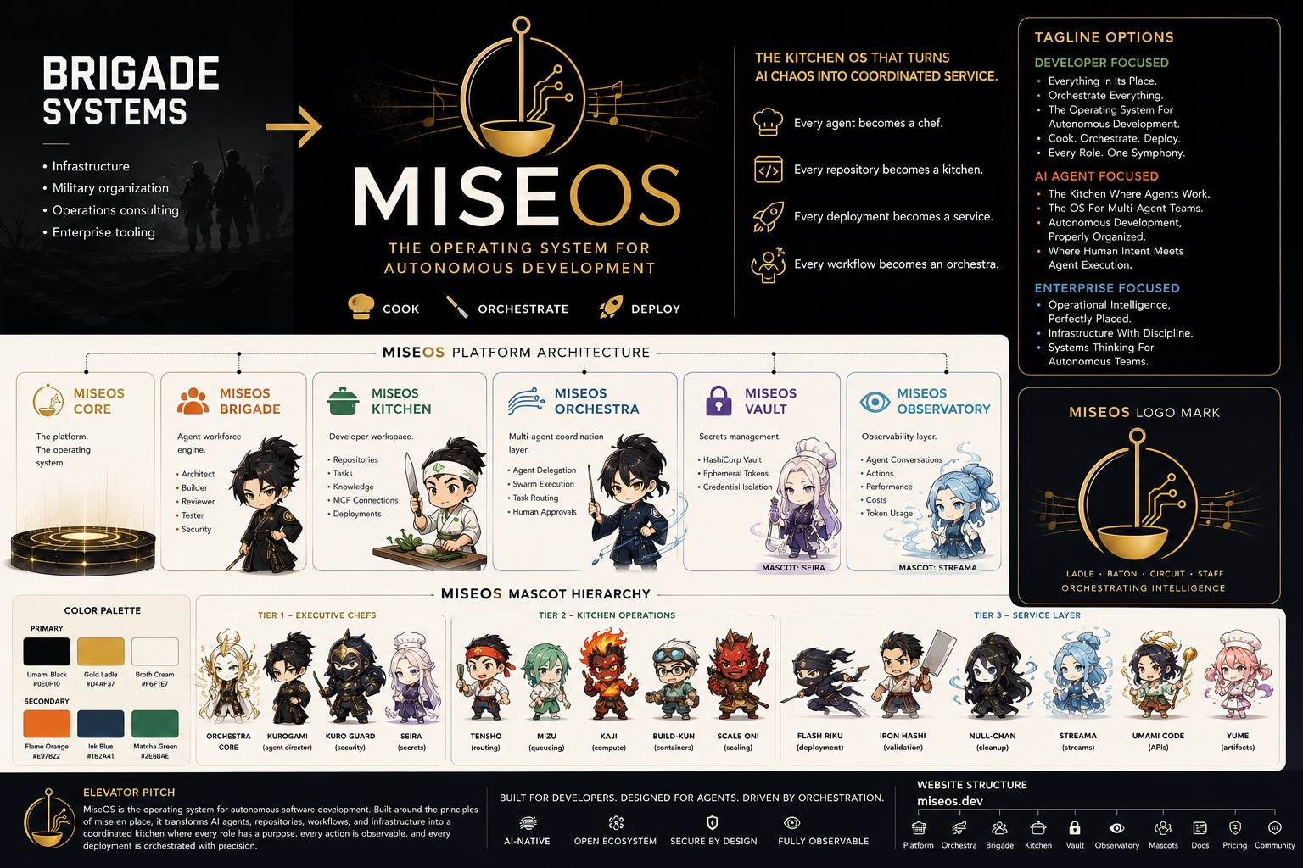
Status: Foundation Canon | Version: 1.0.0 | Scope: MiseOS / GridOps / Chef Brigade 300 / Mise Orchestra / Registry

Canon Declaration
This Bible is the governing reference for MiseOS identity, visual continuity, character usage, product artifacts, GridOps world design, metadata, repositories and publishing. Machine-readable files shipped with this document are normative. The document explains the rules; the registries enforce them.
Layer | Canonical identity | Primary use
MiseOS | Operating system and governance layer | Brand, orchestration, policy and evidence
GridOps | Living operational command world | Spatial interface, graph, timeline and digital twin
Generation One | Founders and product guides | UI, onboarding, documentation and navigation
Chef Brigade 300 | Operational workforce | Executable agent identities and organizational taxonomy
Mise Orchestra | Story and collectible universe | Comics, games, animation and eligible blockchain assets
Registry | Product packages and capabilities | SDKs, schemas, workflows, marketplace and distribution
Chronicles | Serialized story system | Social, web archive and transmedia narrative

Canon authority order
- Approved machine-readable entity record
- Approved asset-registry entry and checksum
- This Canon Bible
- Repository documentation
- Marketing copy and social posts
- Conversation history and drafts
When two sources disagree, the higher source in this order governs. Conversation history is never the final source of truth.

1. Canonical Artwork System
Artwork is divided into three distinct systems. They may collaborate, but they must not be collapsed into one visual category.
System | Visual signature | Canonical use | Forbidden use
Generation One | Clean background, simplified character, readable silhouette | Product guide, tool face, small avatar, onboarding, docs, UI | NFT rarity card unless separately approved
Mise Orchestra Generation Two | Premium black-and-gold cinematic card, technical telemetry, differentiated aura | Chronicles, games, animation, dossiers, collectibles and approved NFTs | Generic product package or registry manifest
Registry artifacts | Product capability card or badge; package-centered identity | Docs, marketplace, SDK/package screens, release announcements | Counted as a character agent or mascot workforce member

Generation One: simplified product-guide language.
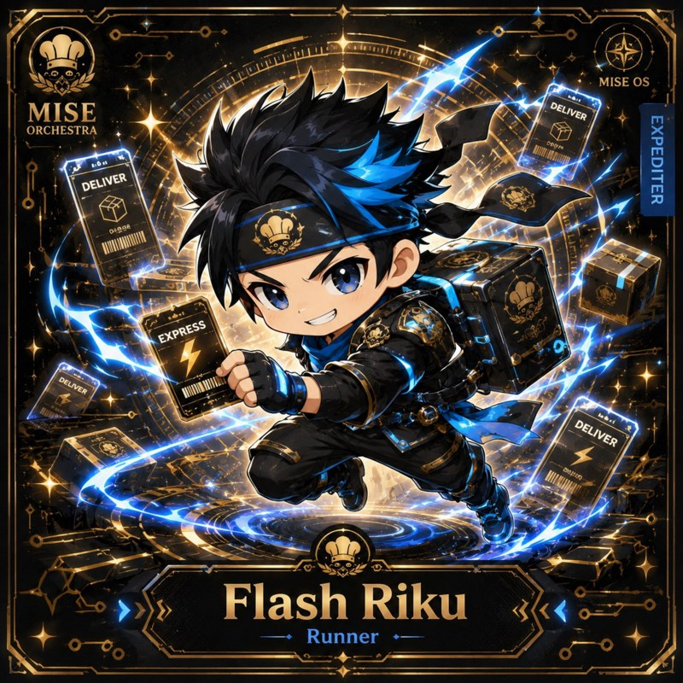
Mise Orchestra Generation Two: premium narrative and collectible language.
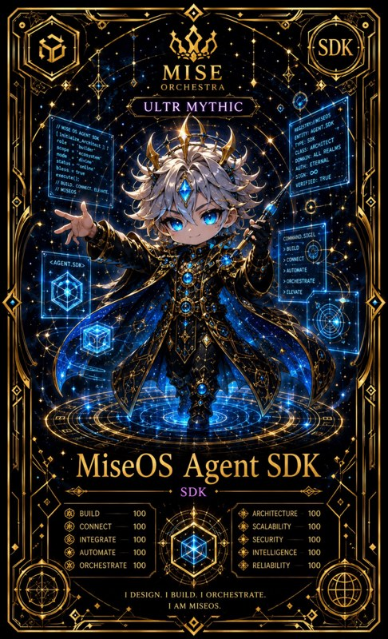
Registry: product capability artifact, not a character-agent record.

Artwork evidence statuses
Status | Meaning
canonical | Explicit source file, entity ID and metadata match; approved for production
canonical-candidate | Strong title/catalog match; awaiting owner approval
provisional | Alias or role-based match; usable only in internal development
unassigned | Artwork exists but no entity match is approved
deprecated | Retained for provenance; prohibited for new production
The accompanying asset registry currently contains 224 page-level and file-level evidence records. The official individual trading-card pack supplies the strongest evidence for its 23 characters.

2. Generation One to Mise Orchestra Mapping
Generation One and Generation Two are related manifestations, not automatically the same character. A mapping requires shared entity identity, role compatibility, visual approval and provenance. Generation One can represent the product-facing interface while the Generation Two form represents the same capability in story, game or collectible contexts.
Mapping type | Rule | Example use
Direct manifestation | Same canonical entity and role across both styles | UI guide opens a Chronicle dossier of the same agent
Tool-face association | Generation One guide represents a registry product, not a workforce agent | Clean guide becomes the face of Agent SDK onboarding
Role archetype | Early artwork expresses a role but has no approved identity | Hold as unassigned until reviewed
No mapping | Visual or role conflicts with current canon | Archive or reassign through canon review

Mapping approval checklist
- One canonical entity ID
- Compatible department and operational role
- Approved name and pronouns
- Source asset and SHA-256 checksum
- Generation-specific use rights
- Model-sheet review
- No collision with another canonical character
The shipped generation-crosswalk.csv covers all current 112 canonical roster records. It intentionally leaves Generation One assignments unapproved rather than guessing.

3. GridOps District Atlas
GridOps is a reconfigurable spatial and graph-native interface. The world is a functional operational model: architecture, routes, barriers, signals and environmental changes must correspond to real system states.
Existing platform architecture reference used as a structural—not literal—world guide.
ID | District | Purpose | Accent
GRID-001 | Singularity Core | Central obsidian-brain operating core | #D4AF37
GRID-010 | GridOps Command Center | Mission control, routing and state overview | #D4AF37
GRID-020 | Pipeline Kitchen | Repository intake through verified release | #E97822
GRID-030 | Platform Kitchen | Golden paths and stable service foundations | #1B2A41
GRID-040 | Reliability Kitchen | Observe, measure and improve | #2E6B4E
GRID-050 | Security Kitchen | Guard, audit and comply | #8B1E2D
GRID-060 | Data & Insight Kitchen | Learn, optimize and evolve | #17A2A4
GRID-070 | Operations Kitchen | Coordinate service execution | #D4AF37
GRID-080 | Registry Citadel | Packages and capability marketplace | #C8A951
GRID-090 | Memory Vault | Governed memory and lineage | #7C3AED
GRID-100 | Human Approval Chamber | Protected decisions and explicit consent | #F8F4E3
GRID-110 | Release Horizon | Final verified publication boundary | #F97316

Spatial grammar
- Repositories are structures or districts, not decorative scenery.
- Workflows are traversable routes with visible state and ownership.
- Agent handoffs are moving packets with source, target and evidence.
- Policy gates are visible barriers with explainable denial or approval states.
- Incidents are distortions localized in service, dependency and time.
- Memory is navigable lineage; unproven memory is visibly marked.
- Release Horizon is inaccessible until required evidence and approvals are complete.

4. Singularity Core Design Specification
The Singularity Core is the visual and functional center of GridOps: an obsidian brain, superconducting circuit machine and liquid-glass interface that can shift between dashboard, graph, world, timeline and virtual-reality modes.
Layer | Visual behavior | System meaning
Obsidian shell | Dark faceted protective body | Governance boundary and system integrity
Liquid-glass lattice | Transparent refractive interior | Visible state, explainability and reconfiguration
Gold circuits | Stable persistent routes | Governance, verified actions and official state
Cyan streams | Fast moving data flow | Telemetry, context and intelligence
Violet field | Deep layered memory volumes | Knowledge graph, vector memory and lineage
Emerald pulses | Healthy rhythmic signals | Reliability and successful verification
Orange routes | Task and deployment movement | Pipelines, execution and release
Crimson fractures | Localized warnings or locks | Security incident, policy violation or blocked action

Interaction modes
- 1D Status: compact state and alerts
- 2D Operations: dashboards, diagrams and evidence panels
- 3D World: districts, agents, routes and incidents
- 4D Timeline: history, causality, lineage and counterfactual playback
- VR Interface: embodied navigation with identical authority and evidence rules
The Core may look mystical, but every effect must communicate an operational meaning. Random magic is not canon.

5. Character Production Rules
Rule | Requirement
Silhouette | Readable at avatar size and recognizable without card text
Tool language | Primary prop directly represents the agent function
Department aura | Use department accent and operational symbolism
Expression set | Neutral, focused, success, warning, failure, collaboration
Model sheet | Front, side, back, three-quarter and scale reference
Continuity | Hair, eyes, clothing, emblem and equipment remain stable
Telemetry | Labels must reflect actual capabilities or clearly marked concepts
Power system | Every augmented ability is a visualization of an operational function
Collaboration | Important missions require handoffs and evidence, not lone-hero solutions
Claims | Never imply an unimplemented capability is deployed

Required character package
- entity.json
- character-bible.md
- model-sheet.png
- avatar.png
- card.png
- expressions.png
- palette.json
- rights.json
- provenance.json
- runtime-contract reference
- comic reference
- optional animation/GLB/audio/AR assets

6. Visual Design System
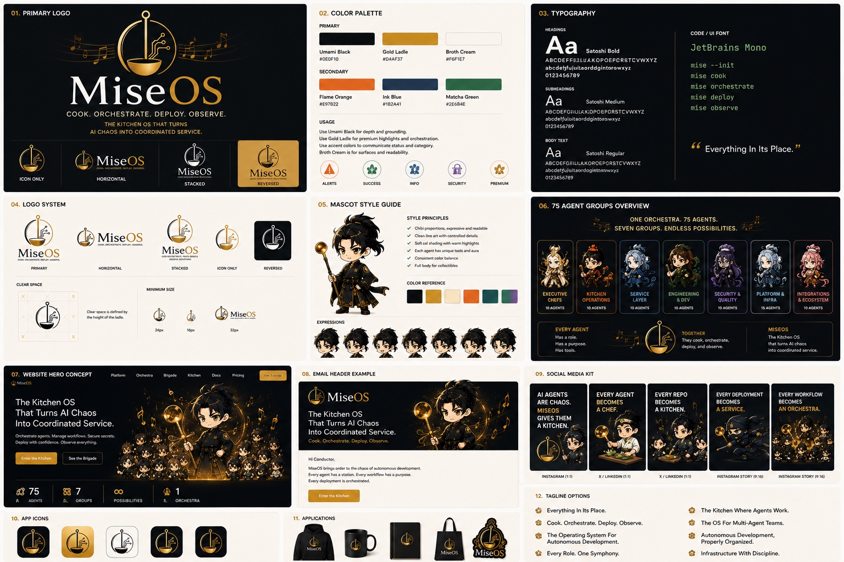
Existing MiseOS brand-system reference.
Token | Meaning | Suggested value
Obsidian | Primary world background | #07090D
Midnight navy | Panels and architectural depth | #12263A
Mise gold | Governance, verified state, official release | #D4AF37
Electric cyan | Data and intelligence | #22D3EE
Emerald | Reliability and healthy systems | #16A34A
Crimson | Security, denial and incident | #DC2626
Pipeline orange | Build, workflow and deployment | #F97316
Memory violet | Knowledge, lineage and orchestration | #7C3AED
Ivory glass | Readable foreground and approval surfaces | #F8F4E3

Typography and composition
- Editorial headline: large, short and spacious.
- Technical secondary text: compact monospaced labels.
- Maximum two speech bubbles per comic panel.
- Use wide negative space in signals and announcements.
- Keep grid-safe content inside a central 1:1 crop even when exporting 4:5.
- Cards may be ornate; product briefs must remain clear and restrained.

7. Comic Production Guide
Every Chronicle must entertain, teach and reveal a real or planned MiseOS capability.
Beat | Purpose
1. Operational problem | A recognizable repository, workflow, policy, reliability or customer problem
2. Character activation | Correct specialist enters because the role matches
3. Augmented power | Operational function becomes visible
4. Collaboration | Handoff to synchronized agents with evidence
5. Capability reveal | Connect the story to a product surface or release state

Comic canon rules
- Technical concepts must survive expert review.
- No important action completes without the required evidence gate.
- A registry product can empower a character but is not itself a character.
- Character victories must preserve permission boundaries.
- Failures and uncertainty are visible, not hidden by confidence.
- Final panel records content ID, canon level and capability status.

Production record
Each episode requires content ID, season, episode, featured entity IDs, products, technical concepts, claim level, source assets, rights, accessibility text, analytics events and export variants.

8. Complete Metadata Schema
The normative JSON Schema is included as schemas/canon-entity-v1.schema.json. All surfaces should reference canonical entity IDs rather than copying names as identity.
Namespace | Purpose
identity | Name, slug, IDs, department, role and generation
canon | Status, confidence, approval and deprecation
design | Palette, silhouette, model sheet, props, expressions and aura
workflow | Inputs, outputs, proof gates, synchronized agents and failure behavior
runtime | Tools, permissions, authority, retries, observability and deployment
media | Image, animation, model, audio and AR references
rights | Owner, license, commercial use, NFT eligibility and restrictions
provenance | Source, checksum, creator, generation method and lineage
analytics | Amplitude IDs, event taxonomy and measurement goals
publishing | Claim level, channels, formats, release and archive state
relationships | Character, package, district, workflow and story links

Status vocabulary
Concept -> Designed -> Specified -> Scaffolded -> Implemented -> Tested -> Integrated -> Deployed -> Public -> Deprecated

9. Asset Registry
The asset registry is the bridge between files and canon. A filename alone is not identity. Every production asset must resolve to an asset ID, source, checksum, entity ID, generation, use rights and approval status.
Required field | Reason
asset_id | Stable cross-surface reference
canonical_entity_id | Prevents name-based collisions
source_file/page | Traceable origin
checksum | Integrity and duplicate detection
match_method | Explains why the asset belongs to the entity
match_status | Controls production eligibility
approved_use | Prevents cross-surface misuse
NFT eligibility | Separates narrative ownership from token permissions
notes | Records exceptions and review decisions
Current evidence summary:
Status | Count
canonical | 23
canonical-candidate | 80
provisional | 44
unassigned | 77

10. Repository Organization and Publishing Pipeline
miseos-canon/
├── canon-bible/
│ ├── MiseOS-Canon-Bible-v1.0.docx
│ └── MiseOS-Canon-Bible-v1.0.pdf
├── entities/
│ ├── characters/001-300/
│ ├── generation-one/
│ ├── registry/
│ ├── districts/
│ └── world-objects/
├── assets/
│ ├── source/
│ ├── approved/
│ ├── deprecated/
│ ├── derivatives/
│ └── checksums/
├── schemas/
├── gridops/
│ ├── atlas/
│ ├── singularity-core/
│ ├── captures/
│ └── unity/
├── chronicles/
│ ├── story-bible/
│ ├── seasons/
│ ├── scripts/
│ └── exports/
├── nft/
├── api/
├── analytics/
├── publishing/
└── .github/workflows/

Publishing gates
Gate | Must be true
Asset match | Canonical IDs, asset IDs and provenance attached
Technical review | Concept and product claims match real readiness
Canon review | Character, world and relationships follow this Bible
Rights review | Use, commercial and NFT permissions are explicit
Approval | Copy, accessibility, analytics and exports complete
Measurement | Published content records performance and learnings
Archive | Final files and metadata remain reproducible

Automation requirements
- Validate JSON Schema on pull request.
- Reject duplicate entity and asset IDs.
- Verify referenced files and SHA-256 checksums.
- Block NFT metadata unless nft_eligible=true and rights are complete.
- Block public publishing when public_claim_level exceeds readiness status.
- Generate content manifests and web archives from canonical metadata.
- Preserve deprecation history instead of deleting old canon.

Appendix A - Canon Counts and Boundaries
Category | Current canon
Current canonical characters | 112
Planned expansion characters | 188 (agents 113-300)
Chef Brigade target | 300 character agents
Registry manifests | 23 product infrastructure records
Generation One source pages | 76 early visual references
Mise Orchestra PDF card pages indexed | 96 visible card records
Official individual trading-card pack | 23 characters with PNG + ERC-721 metadata
The current expanded public model is 300 character agents + 23 registry manifests = 323 MiseOS ecosystem items. Readiness and approval status must remain explicit; a planned agent is not automatically implemented or publicly available.

Appendix B - Initial Verified and Candidate Artwork
Asset ID | Entity | Generation | Status | Source | Page
MISE-G2-P001 | Flash Riku | Mise Orchestra Generation Two | canonical-candidate | 1E3334AB-3111-4E81-AECF-71CB094259F8.pdf | 1
MISE-G2-P006 | Ledger Ladle | Mise Orchestra Generation Two | canonical-candidate | 1E3334AB-3111-4E81-AECF-71CB094259F8.pdf | 6
MISE-G2-P010 | Merge Sentinel | Mise Orchestra Generation Two | canonical-candidate | 1E3334AB-3111-4E81-AECF-71CB094259F8.pdf | 10
MISE-G2-P011 | Felix Rollback | Mise Orchestra Generation Two | canonical-candidate | 1E3334AB-3111-4E81-AECF-71CB094259F8.pdf | 11
MISE-G2-P012 | Ticket Tactician | Mise Orchestra Generation Two | canonical-candidate | 1E3334AB-3111-4E81-AECF-71CB094259F8.pdf | 12
MISE-G2-P013 | Hugo Matrix | Mise Orchestra Generation Two | canonical-candidate | 1E3334AB-3111-4E81-AECF-71CB094259F8.pdf | 13
MISE-G2-P014 | Mizu | Mise Orchestra Generation Two | canonical-candidate | 1E3334AB-3111-4E81-AECF-71CB094259F8.pdf | 14
MISE-G2-P015 | Release Conductor | Mise Orchestra Generation Two | canonical-candidate | 1E3334AB-3111-4E81-AECF-71CB094259F8.pdf | 15
MISE-G2-P016 | Garnish Ghost | Mise Orchestra Generation Two | canonical-candidate | 1E3334AB-3111-4E81-AECF-71CB094259F8.pdf | 16
MISE-G2-P018 | Ivun Cache | Mise Orchestra Generation Two | canonical-candidate | 1E3334AB-3111-4E81-AECF-71CB094259F8.pdf | 18
MISE-G2-P020 | Crate Courier | Mise Orchestra Generation Two | canonical-candidate | 1E3334AB-3111-4E81-AECF-71CB094259F8.pdf | 20
MISE-G2-P023 | DORA Daichi | Mise Orchestra Generation Two | canonical-candidate | 1E3334AB-3111-4E81-AECF-71CB094259F8.pdf | 23
MISE-G2-P024 | Queue Quartz | Mise Orchestra Generation Two | canonical-candidate | 1E3334AB-3111-4E81-AECF-71CB094259F8.pdf | 24
MISE-G2-P027 | Runtime Riku | Mise Orchestra Generation Two | canonical-candidate | 1E3334AB-3111-4E81-AECF-71CB094259F8.pdf | 27
MISE-G2-P028 | Cost Kaito | Mise Orchestra Generation Two | canonical-candidate | 1E3334AB-3111-4E81-AECF-71CB094259F8.pdf | 28
MISE-G2-P029 | Orchestra Core | Mise Orchestra Generation Two | canonical-candidate | 1E3334AB-3111-4E81-AECF-71CB094259F8.pdf | 29
MISE-G2-P033 | Scorecard Shin | Mise Orchestra Generation Two | canonical-candidate | 1E3334AB-3111-4E81-AECF-71CB094259F8.pdf | 33
MISE-G2-P037 | Kaji | Mise Orchestra Generation Two | canonical-candidate | 1E3334AB-3111-4E81-AECF-71CB094259F8.pdf | 37
MISE-G2-P038 | Preview Yuki | Mise Orchestra Generation Two | canonical-candidate | 1E3334AB-3111-4E81-AECF-71CB094259F8.pdf | 38
MISE-G2-P041 | Iron Hashi | Mise Orchestra Generation Two | canonical-candidate | 1E3334AB-3111-4E81-AECF-71CB094259F8.pdf | 41
MISE-G2-P043 | Velvet Vesper | Mise Orchestra Generation Two | canonical-candidate | 1E3334AB-3111-4E81-AECF-71CB094259F8.pdf | 43
MISE-G2-P044 | Tariq Notesmith | Mise Orchestra Generation Two | canonical-candidate | 1E3334AB-3111-4E81-AECF-71CB094259F8.pdf | 44
MISE-G2-P045 | Scale Oni | Mise Orchestra Generation Two | canonical-candidate | 1E3334AB-3111-4E81-AECF-71CB094259F8.pdf | 45
MISE-G2-P046 | Evidence Scribe | Mise Orchestra Generation Two | canonical-candidate | 1E3334AB-3111-4E81-AECF-71CB094259F8.pdf | 46
MISE-G2-P047 | Yume | Mise Orchestra Generation Two | canonical-candidate | 1E3334AB-3111-4E81-AECF-71CB094259F8.pdf | 47
MISE-G2-P051 | Schema Sora | Mise Orchestra Generation Two | canonical-candidate | 1E3334AB-3111-4E81-AECF-71CB094259F8.pdf | 51
MISE-G2-P054 | Reserve Rune | Mise Orchestra Generation Two | canonical-candidate | 1E3334AB-3111-4E81-AECF-71CB094259F8.pdf | 54
MISE-G2-P055 | Vacuum Vesper | Mise Orchestra Generation Two | canonical-candidate | 1E3334AB-3111-4E81-AECF-71CB094259F8.pdf | 55
MISE-G2-P057 | Anomaly Aki | Mise Orchestra Generation Two | canonical-candidate | 1E3334AB-3111-4E81-AECF-71CB094259F8.pdf | 57
MISE-G2-P059 | Flavor Forager | Mise Orchestra Generation Two | canonical-candidate | 1E3334AB-3111-4E81-AECF-71CB094259F8.pdf | 59
MISE-G2-P061 | Streama | Mise Orchestra Generation Two | canonical-candidate | 1E3334AB-3111-4E81-AECF-71CB094259F8.pdf | 61
MISE-G2-P063 | Nudge Neko | Mise Orchestra Generation Two | canonical-candidate | 1E3334AB-3111-4E81-AECF-71CB094259F8.pdf | 63
MISE-G2-P064 | Ladle Lumen | Mise Orchestra Generation Two | canonical-candidate | 1E3334AB-3111-4E81-AECF-71CB094259F8.pdf | 64
MISE-G2-P065 | Pantry Paladin | Mise Orchestra Generation Two | canonical-candidate | 1E3334AB-3111-4E81-AECF-71CB094259F8.pdf | 65
MISE-G2-P066 | Guardrail Goro | Mise Orchestra Generation Two | canonical-candidate | 1E3334AB-3111-4E81-AECF-71CB094259F8.pdf | 66
MISE-G2-P067 | Allergen Oracle | Mise Orchestra Generation Two | canonical-candidate | 1E3334AB-3111-4E81-AECF-71CB094259F8.pdf | 67
MISE-G2-P070 | Umami Code | Mise Orchestra Generation Two | canonical-candidate | 1E3334AB-3111-4E81-AECF-71CB094259F8.pdf | 70
MISE-G2-P071 | Incident Kitsune | Mise Orchestra Generation Two | canonical-candidate | 1E3334AB-3111-4E81-AECF-71CB094259F8.pdf | 71
MISE-G2-P074 | Grafana Mei | Mise Orchestra Generation Two | canonical-candidate | 1E3334AB-3111-4E81-AECF-71CB094259F8.pdf | 74
MISE-G2-P075 | Garnish Ghost | Mise Orchestra Generation Two | canonical-candidate | 1E3334AB-3111-4E81-AECF-71CB094259F8.pdf | 75
MISE-G2-P080 | Recipe Ranger | Mise Orchestra Generation Two | canonical-candidate | 1E3334AB-3111-4E81-AECF-71CB094259F8.pdf | 80
MISE-G2-P081 | Portal Rei | Mise Orchestra Generation Two | canonical-candidate | 1E3334AB-3111-4E81-AECF-71CB094259F8.pdf | 81
MISE-G2-P082 | Build-Kun | Mise Orchestra Generation Two | canonical-candidate | 1E3334AB-3111-4E81-AECF-71CB094259F8.pdf | 82
MISE-G2-P084 | Harvest Hex | Mise Orchestra Generation Two | canonical-candidate | 1E3334AB-3111-4E81-AECF-71CB094259F8.pdf | 84
MISE-G2-P087 | Nina Promoter | Mise Orchestra Generation Two | canonical-candidate | 1E3334AB-3111-4E81-AECF-71CB094259F8.pdf | 87
MISE-G2-P089 | Token Toshi | Mise Orchestra Generation Two | canonical-candidate | 1E3334AB-3111-4E81-AECF-71CB094259F8.pdf | 89
MISE-G2-P090 | Kuro Guard | Mise Orchestra Generation Two | canonical-candidate | 1E3334AB-3111-4E81-AECF-71CB094259F8.pdf | 90
MISE-G2-P091 | CVE Kumo | Mise Orchestra Generation Two | canonical-candidate | 1E3334AB-3111-4E81-AECF-71CB094259F8.pdf | 91
MISE-G2-P092 | Scale Oni | Mise Orchestra Generation Two | canonical-candidate | 1E3334AB-3111-4E81-AECF-71CB094259F8.pdf | 92
MISE-G2-P094 | Prep Pulse | Mise Orchestra Generation Two | canonical-candidate | 1E3334AB-3111-4E81-AECF-71CB094259F8.pdf | 94
The complete list is provided in registry/asset-registry.csv and .json. This appendix is intentionally abbreviated for readability.

Appendix C - Approval Record
Field | Value
Canon version | 1.0.0
Document status | Foundation canon - requires owner sign-off for provisional mappings
Normative files | canon-entity schema, asset registry, generation crosswalk, district atlas, publishing pipeline
Next review | After Generation One mapping and Alko/Bruno/Lila/Evidence Scribe artwork approval
Change policy | Semantic versioning; every breaking canon change increments major version

